**An Introduction to Self-heating and Spontaneous Ignition**

Click <https://www.youtube.com/watch?v=EOxpLRpRey0> link to open resource.

**Spontaneous Combustion real or not**

Spontaneous Combustion video

Click <https://www.youtube.com/watch?v=Fn1Wwvvnzvc> link to open resource.

**Spontaneous Combustion in Power Plants - Causes &Do -Not to do**

Spontaneous Combustion in Power Plants - Causes &Do -Not to do video

Click <https://www.youtube.com/watch?v=GlPoD1QR3EQ> link to open resource.

**Fire Heat Heat Release Rate (HRR) example**

 Fire Heat Heat Release Rate (HRR) example video

Click <https://www.youtube.com/watch?v=RMyCOlcP154> link to open resource.

**Understanding the Basics: Heat Release Rate Vs Temperature**

**Understanding the Basics: Heat Release  Rate Vs Temperature video**

Click <https://www.youtube.com/watch?v=h8o-z_mV-V4> link to open resource.

**Large diameter pool fire heat release rate (HRR)**

Large diameter pool fire heat release rate (HRR) video

Click <https://www.youtube.com/watch?v=VY8UORfd68g> link to open resource.

# What’s the Difference Between Dry Hydrant and Wet Hydrant?

The dry hydrants, aka the standpipe, are commonly used by firefighters as the main water supply in rural areas where the municipal water system is a luxury and can’t be easily accessible. Typically, an unpressured, permanently installed pipe, the dry hydrant is well below the water level of a lake or pond at one end, usually with a strainer to prevent debris or foreign objects from entering the pipe.

The other end of the pipe, however, is located on the surface of the ground with a hard sleeve connector on it. A pumper fire engine drafts water from the lake or pond, when needed, with a primer by vacuuming the air out of the dry hydrant as well as the hard sleeve and fire engine pump.

With the pump intake at lower pressure, the lake water is partially forced into the above-ground dry hydrant, and all the way into the pump through the hard sleeve, due to atmospheric pressure on the water along with its own weight. Now the water is available when pumped by the engine’s centrifugal pump.

Installed close to developed water supplies, a dry hydrant can be found in most areas without ready water accessibility which may be rural or not within easy reach of the public water system.

In case of a fire, local dry hydrants play a critical role of providing adequate water in an effective and convenient way to fight the fire. These hydrants, utilizing a non-pressurized pipe system, are installed for good and connected to nearby lakes, ponds, streams, or even reservoirs in these areas. Exempt from standard hydrant testing, they need less maintenance and are more cost-effective than other types of hydrant.

Now we’d like to provide interesting insights into how these non-pressurized hydrants operate.

A dry hydrant is by appearance highly identifiable as a permanently installed aboveground pipe located close to any form of water source. What can’t be seen is the other end of the pipe buried underground connecting with the water source through a strainer that prevents the pipe from getting clogged up by debris.

In this case, firefighters need to use an adapter while pumping lake water with a fire engine’s pump by vacuuming the air out of the dry crank. By doing so, lower pressure will be created in the pump intake that forces enough water into the aboveground hydrant and then into the pumper.

The way how a dry hydrant operates can be easily understood if you know the function of its two main parts — a curve pipe and a strainer. Dry hydrants can provide water supply to areas where standard hydrants are not accessible.

**What’s the difference between a wet and dry barrel hydrant?**

Wet barrel hydrants are different from dry barrel ones in terms of styles and applications. Literally “wet” and “dry” mean whether the barrel of the above ground hydrant holds water or not after use.

**Dry Barrel Hydrants**

Water in the barrel of this type of hydrant is drained away or pumped out when not in use. Its shut-off valve is located below the surface of the ground. Because the aboveground hydrant is dry after use, it won’t be frozen during cold weather.

**Wet Barrel Hydrants**

In contrast to dry barrel hydrants, the wet barrel hydrant, with aboveground shut-off valves, holds no water in the barrel when not in use. With the valve of each outlet operating independently, this type of hydrant has an advantage over its dry barrel counterpart due to easy access to the aboveground mechanical parts for maintenance and adjustments, which of course turns out to be more economical.

Despite all the advantages, the Achilles’ heel of the wet barrel hydrants is freezing, and that’s why they are installed in areas with warm climates.

**What is the Difference Between a Wet Barrel and Dry Barrel Hydrant?**

Geographically speaking, dry barrel hydrants are commonly used in the cold regions because their underground valves ensure that no water will be left above ground, thus preventing themselves from freezing or breaking.

On the other hand, wet barrel hydrants, always filled with water from top to bottom, are frequently seen in the warm regions. In Arizona, for example, both types of hydrants are installed, but the wet barrel hydrants outnumber the dry ones.

Therefore, what is required is a customized maintenance program to keep this type of hydrant in good condition because the routine maintenance of a wet barrel hydrant is different from that of a dry barrel hydrant.

Ref: https://www.mafco-fire.com/whats-the-difference-between-dry-hydrant-and-wet-hydrant/

# Fire Hydrant Colors: Their NFPA Spectrum and Meaning

## Fire hydrants are painted different colors to win the trifecta of maintenance, safety, and precise communication

Fire hydrants are reservoirs for life-saving water. Many people are unaware, however, that the paint color and select markings on a specific hydrant convey key information to aid in firefighting and safety. How much water will be available, and how quickly? Is the hydrant water potable? Are there precautions when opening and closing the hydrant? Will there be enough water pressure? Fire hydrant colors and markings can answer all of these questions.

Fire hydrant colors are actually less descriptive of the hydrant than they are revealing of the machinations humming below ground: the pipe, the main, and the flow. The hydrant is the tip of the iceberg, signifying through its color what lies beneath the surface in terms of functionality. In this article, we put some meaning behind fire hydrant colors.

**The standardization of fire hydrant colors**

Knowledge of hydrant colors communicates key information that allows snap decision-making before hooking up a fire hose, but this highly codified color system is not uniform across the United States.

The National Fire Protection Association (NFPA) has defined hydrant color coding, yet many jurisdictions have also developed specific color-code charts and rules of their own. At the same time, the Occupational Safety and Health Administration (OSHA) and the American Water Works Association suggest additional national color water safety recommendations.

[NFPA 291](https://www.nfpa.org/codes-and-standards/all-codes-and-standards/list-of-codes-and-standards/detail?code=291): Recommended Practice for Fire Flow Testing and Marking of Hydrants covers labeling and hydrant colors, but this document can ultimately act only as a guideline rather than a definitive handbook of all hydrant color meanings.

The result of NFPA 291, other guidelines, and local jurisdictional choices and laws is an imperfect system that requires specific training on hydrant color coding for every fire district. It is possible to make some generalizations about color, however, because NFPA’s recommendations are commonly used.

This article covers NFPA, [OSHA](https://www.todayifoundout.com/index.php/2013/01/fire-hydrant-colors-actually-mean-something/), and [American Water Works guidelines](http://www.dep.state.pa.us/dep/deputate/waterops/Redesign/TablesNFormulas/Pages/firehydrantcolor.htm), while offering illustrative examples of how local practices in color-coding may change the meaning of each color. But before getting into which hydrant color indicates what, let’s outline how fire hydrants work and how they contribute to fire safety.

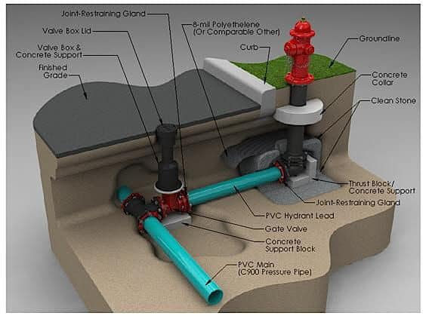

## The anatomy of a fire hydrant

A fire hydrant is an aboveground pipe fitting designed to allow a quick access port for fire hoses, which can then be attached to the fire truck to divide the water stream into several more streams (via additional fire hoses). Multiple fire hoses are key to fighting large fires successfully.

Fire hydrants are deceptively simple in design but, for optimal use, they require a reliable water source and regular maintenance. From the time hydrants first appeared on city corners in urban American settings in 1801, these mainstays of firefighting haven’t changed their basic stripes: they remain pipe fittings with a nut or bolt to release water, and connection points for fire hose hookup. A significant innovation, however, is increasingly common [Storz hookups that enable a quicker, more reliable connection than threaded connections](https://blog.qrfs.com/158-storz-fdcs-and-fire-hydrant-storz-connections-adapters-or-integral-storz/).

The majority of hydrants tap into potable or drinking water supplies, although some draw from ponds, lakes and other non-potable sources. Regardless of color or location, all hydrants are placed directly above a riser, or vertical channel, that reaches down a few feet into a larger horizontal pipe (whether a feeder or distributor) that eventually connects to the water main.

The hydrant itself doesn’t include a mechanical device to alter water pressure: it acts only as an accessible valve that is either in “on” or “off” mode and channels a larger water supply. For a simple but succinct explanation of hydrant mechanics, this video explains how they operate:

## Dry and wet barrel fire hydrants

Fire hydrants are built in two basic varieties, depending on climate. In US regions where the temperature drops, dry barrel hydrants are installed because any water above ground, including the water stored in the hydrant barrel itself, has the potential to freeze. The valve in dry barrel models is situated below the frost line; a long, vertical valve runs through the riser to a nut on top of the hydrant. Turning this top nut allows water to flow into the hydrant and, subsequently, the fire hose.

Wet barrel hydrants operate only in warmer climates and as the name suggests, the “barrel” (or above-ground portion) is always filled with water. It is literally a wet barrel under pressure. This type of hydrant costs less to build, install, and maintain.

Most US population centers experience regular freezes and therefore the dry barrel design is more common. Dry versus wet barrels are important distinctions that are not commonly demarcated by color.

Again, fire hydrants are access points; the hydrants and their bolts do not allow for any variability or control of water measurements. For this reason, hydrant colors are the best method of informing firefighters about how much water they will be able to pump. Higher-flow hydrants are typically placed in denser population areas, where larger structures need more pressure and gallons per minute. High-flow hydrants are also spaced farther apart in any given area since each hydrant is capable of providing more water.

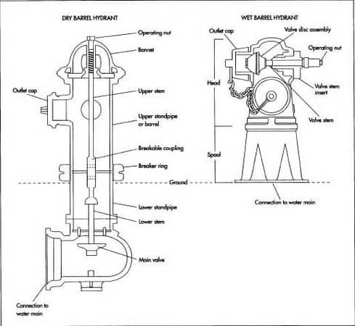Diagrams of a dry barrel (left) and wet barrel hydrant. Source: [Clear Plastic Tubing](https://clearplastictubing.blogspot.com/2017/09/difference-between-fire-hydrant-and.html)

## Who decides fire hydrant color?

At first glance, color may seem like a minor detail but the hydrant color system functions in three important ways: first, colors give firefighters and other professionals instant information about the unit’s status and water flow; second, a colored hydrant can indicate the water source; and third, painted hydrants indicate the likelihood that regular upkeep and maintenance are being performed.

NFPA 291 is a “recommended practice;” thus, its color chart is not enforceable unless a jurisdiction determines that it is. Many municipalities and fire departments choose to follow NFPA strictly, others use some of the recommendations but make exceptions, and there are some areas that create their own unique color code.

OSHA also publishes [standards](https://www.osha.gov/laws-regs/regulations/standardnumber/1926/1926.150) to address hazards and protect water safety which encompasses water coming from hydrants. OSHA [advises](https://www.todayifoundout.com/index.php/2013/01/fire-hydrant-colors-actually-mean-something/) using color to distinguish between potable and non-potable water sources—with violet indicating the latter—and also recommends black paint for defunct or temporarily non-working hydrants.

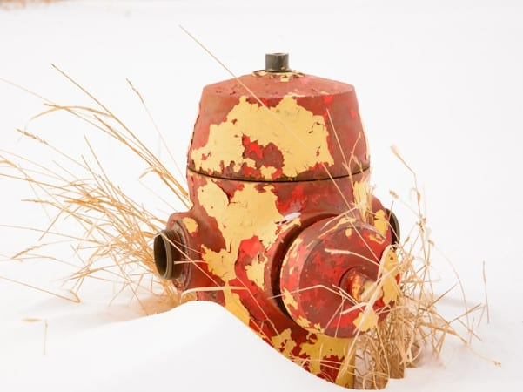Faded paint indicating a lack of regular maintenance. Note the missing plugs and bolt cap.

## The basic NFPA fire hydrant color palette

### Hydrant barrels are red or yellow

Red and yellow barrels have specific meanings. While caps (or bonnets) may be painted a different color to indicate their flow rate (which will be outlined in the next section), many hydrant barrels are painted a single, uniform color. This reflects NFPA 291, which specifies the following:

**All public fire hydrants should have yellow barrels**and NFPA recommends using a reflective color:

**From the 2019 edition of NFPA 291**

**5.2.1.1** All barrels are to be chrome yellow except in cases where another color has already been adopted.

**5.2.1.3** For rapid identification at night, it is recommended that the capacity colors be of a reflective-type paint.

**Red barrels are recommended for any private fire hydrant** that is on public property. NFPA 291 addresses this using nearly identical verbiage in two sections (and the reflective paint recommendation also applies):

**5.2.1.9** [and **5.2.5.2**] When private hydrants are located on public streets, they should be painted red or another color to distinguish them from public hydrants.

Other barrel colors commonly adopted due to various local requirements are reflective white and silver. And in some jurisdictions—for example, the state of Texas—the color black has been legislated for non-working hydrants. NFPA 291 does not mention the color black but it does address what to do in case of a permanently nonworking hydrant (remove it) or a temporarily nonworking unit (secure a bag over it):

**5.2.2 Permanently Inoperative Hydrants.** Fire hydrants that are permanently inoperative or unusable should be removed.

**5.2.3 Temporarily Inoperative Hydrants.** Fire hydrants that are temporarily inoperative or unusable should be wrapped or otherwise provided with temporary indication of their condition.

### Hydrant bonnets and caps

Bonnets and caps are also commonly painted to follow NFPA guidelines for arguably the most important piece of data: water flow. The color of the cap concisely summarizes the water available at a given hydrant and, ultimately, the rate of flow and pressure are the two biggest safety concerns for firefighters.

When estimating the size of the fire they are up against, firefighters want to know they will have enough water. The flow has virtually nothing to do with the hydrant itself, however. Flow rate [depends on](https://www.firehouse.com/operations-training/hoselines-water-appliances/article/12373752/water-supply-for-fireground-operations-hydrants-ldh-water-main-firefighter-training) the size of pipe, including the water main, and whether the main below the hydrant is a primary feeder, secondary feeder, or distributor. Hydrants above larger mains (12” to 16”) are more likely to have high flow due to the size of the pipe, although feeder pipe diameters vary widely in size. A high flow rate is generally considered 1,500 GPM (gallons per minute).

NFPA classifies hydrants into four classes:

**From the 2019 edition of NFPA 291**

**5.1 Classification of Hydrants.** Hydrants should be classified in accordance with their rated capacities [at 20 psi (1.4 bar) residual pressure or other designated value] as follows:

(1) Class AA — Rated capacity of 1500 gpm (5700 L/min) or greater

(2) Class A — Rated capacity of 1000–1499 gpm (3800–5699 L/min)

(3) Class B — Rated capacity of 500–999 gpm (1900–3799 L/ min)

(4) Class C — Rated capacity of less than 500 gpm (1900 L/ min)

In the case of a smaller, non-structural fire—for example, a burning vehicle or yard debris—the lowest flow rate (under 500 GPM) could be sufficient. (This rate is categorized “inadequate” by NFPA). For a multi-story home or multi-story apartment building, a higher flow rate is needed.

To mark flow rate, NFPA 291 outlines painting the tops and nozzle caps with the following scheme **[brackets added]**:

**5.2.1.2** The tops and nozzle caps should be painted with the following capacity-indicating color scheme to provide simplicity and consistency with colors used in signal work for safety, danger, and intermediate condition:

(1) Class AA — Light blue **[1,500 GPM or greater]**

(2) Class A — Green **[1,000—1,499 GPM]**

(3) Class B — Orange **[500–999 GPM]**

(4) Class C — Red **[less than 500 GPM]**

Note that this exact color scheme is [also recommended](http://www.dep.state.pa.us/dep/deputate/waterops/Redesign/TablesNFormulas/Pages/firehydrantcolor.htm) by The American Water Works Association.

During routine maintenance of hydrants (even those used infrequently) ascertaining an accurate flow rate is the primary aim because low flow will inevitably impede firefighting. [Inspectors utilize pitot gauges to inspect and evaluate pressure](https://blog.qrfs.com/46-how-to-use-a-pitot-gauge-for-hydrant-flow-testing/) in the surrounding pipes in order to assess this flow.

Additionally, water safety issues can arise if pipes in the vicinity of the hydrant lose pressure. A pressure drop below 20 PSI can impact the public water supply since contaminated groundwater may enter a freshly created low-pressure piping system. Pipes that drop pressure can affect the whole system, so regular maintenance by Fire Marshalls and other officials is critical with all hydrants, whether they are frequently used or not.

### Additional NFPA fire hydrant markings

Finally, certain customized markings can be found on different hydrants to provide specific information including low PSI, rated capacity, group-flow capacity, and location of flush hydrants:

**From the 2019 edition of NFPA 291**

**5.2.1.4** Hydrants rated at less than 20 psi (1.4 bar) should have the rated pressure stenciled in black on the hydrant top.

**5.2.1.5** In addition to the painted top and nozzle caps, it can be advantageous to stencil the rated capacity of high-volume hydrants on the top.

**5.2.1.7** Where a group of hydrants can be used at the time of a fire, some special marking designating group-flow capacity may be desirable.

**5.2.1.8** Marking on private hydrants within private enclosures is to be done at the owner’s discretion.

**5.2.4 Flush Hydrants.** Location markers for flush hydrants should carry the same background color as stated above for class indication, with such other data stenciled thereon as deemed necessary.

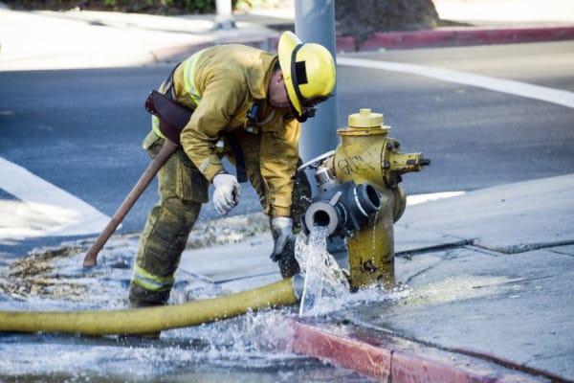A hydrant in standard yellow (indicating public hydrant) with hose adapters.

## Other select fire hydrant markings

**Dead-end water mains and regulated zones**

 In certain locales, the water pressure must be regulated; [there are](http://www.firehydrant.org/info/hycolor.html) “neighborhoods in very high pressure areas where the water mains themselves are fed through pressure regulators so that water supplied to domestic users is not so extreme that it could damage water meters and plumbing.” In what are known as “Regulated Zones,” firefighters are responsible for ensuring hydrant valves are shut off gradually to avoid putting too much pressure on the pipe, regulator devices used, or to the water main itself.

In addition, a hydrant’s location within “dead-end mains”—which are “only supplied with water from one end”—may be marked:

In such instances, fire companies pumping “upstream” from other companies can impact water supply to their “downstream” counterparts. By marking the hydrants and direction of water flow, our engine companies can be made aware of the situation and coordinate appropriately among themselves to ensure the available water is adequately shared.

[These Regulated Zones](https://www.fmsystems-inc.com/fire-hydrant-color-code-table/) may use additional special markings on hydrant caps that are not specified by NFPA, such as:

* An orange-colored “R” inside a circle indicates that the hydrant is in a regulated pressure zone.
* An orange arrow indicates the direction of water flow on a dead-end main.
* An orange arrow and a vertical bar indicate the last hydrant and the direction of water flow on a dead-end main.

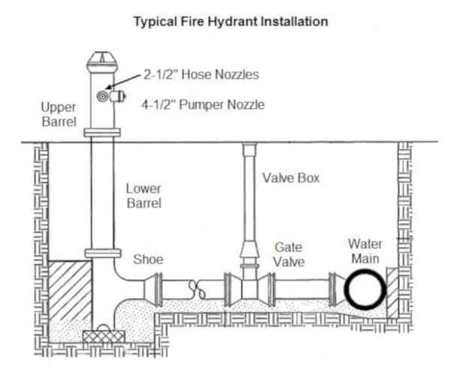A typical fire hydrant installation has standard elements below ground leading to a water main. Source: [Engineered Software](http://kb.eng-software.com/eskb/pipe-flo/modeling-piping-system-devices/modeling-a-fire-hydrant)

### Non-potable or potable water source

OSHA recommends using the color violet to indicate that the water source is non-potable. While this regulation is helpful for water safety, it has little effect on firefighters’ top priority: water flow.

A San Francisco city hydrant with a blue cap in the Jones Street tank lower zone, for emergency use as part of the Auxiliary Water Supply System (AWSS). Source: [Wikipedia](https://en.wikipedia.org/wiki/San_Francisco_Fire_Department_Auxiliary_Water_Supply_System#/media/File:Auxiliary_Water_Supply_System_fire_hydrant.JPG)

## A lack of uniformity and the San Francisco example

The lack of uniformity in color coding can result in minor or major local digressions from NFPA 291. A foolproof color-coding system does not exist nationally, but almost all local fire districts do have a hydrant color code in place. It is unwise to assume that colors strictly follow NFPA 291, and local fire hydrant schema should always be consulted. Professionals in hydrant maintenance are regularly trained in painting standards, including following the local guidelines.

As with all fire safety issues, educating firefighters, government officials, and even citizens on color schemes should be undertaken whenever possible, and keeping updated guidelines, such as [these from Spokane, WA](https://static.spokanecity.org/documents/fire/prevention/forms/hydrant-guide.pdf), is appropriate public administration practice.

The city of San Francisco offers a confusing lesson on how hydrant colors might vary from national standards. Following the [1906 earthquake](https://en.wikipedia.org/wiki/1906_San_Francisco_earthquake), the city developed the Auxiliary Water Supply System (AWSS) which is also known as the HPFS, or High-Pressure Fire System. Various water reservoirs, cisterns, suction connections, pump stations, and even fireboats now form an intricate network of fresh and saltwater resources for emergency back-up.

A total of 1,889 color-coded hydrants can be found in San Francisco. All have colored caps that could be blue, black, or red, depending on their location and water source. In addition, the city has thin and thick hydrants (once dubbed “Laurel and Hardy” hydrants), and the sizes reveal information about their pressure.

San Francisco developed its overall water system as a response to the 1906 disaster, along with the unique color schemes. And just to make things interesting, a lone hydrant, painted in gold, is left to [commemorate](https://www.atlasobscura.com/places/the-golden-fire-hydrant-san-francisco-california) the earthquake. Near Dolores Park in the Mission District, this hydrant supplied water when all others failed.

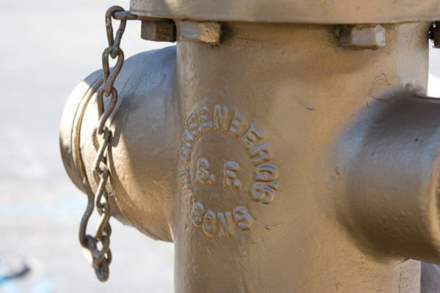The golden fire hydrant in San Francisco’s Mission District. Source: [bgreenlee Creative Commons](https://www.flickr.com/photos/bgreenlee/419103045/sizes/z/in/photostream/)

## Color coding works despite a diversity of schemes

The painting and labeling of fire hydrant barrels and caps give firefighters and other officials various pieces of data, notably water flow and water source. Colors also contribute to regular maintenance, since older hydrants that show severe fading are prime candidates for testing and repainting to meet code.

NFPA recommendations aren’t adhered to in all jurisdictions, but many municipalities have adopted all or part of them. Despite this lack of uniformity across the US, fire hydrant color-coding remains a valuable system for maintaining fire protection readiness and public safety.

Ref: https://blog.qrfs.com/286-fire-hydrant-colors-their-nfpa-spectrum-and-meaning/Ss

## What is Fault Tree Analysis

Fault tree analysis (FTA) is a graphical tool to explore the causes of system level failures. It uses boolean logic to combine a series of lower level events and it is basically a top-down approach to identify the component level failures (basic event) that cause the system level failure (top event) to occur. Fault tree analysis consists of two elements “events” and “logic gates” which connect the events to identify the cause of the top undesired event.

Fault tree analysis is an easier method than the [Failure Mode and Effects Analysis (FMEA)](https://sixsigmastudyguide.com/failure-mode-effects-analysis-fmea/)as it focuses on all possible system failures of an undesired top event. Whereas [FMEA](https://sixsigmastudyguide.com/failure-mode-effects-analysis-fmea/) conducts analysis to find all possible system failure modes irrespective of their severity.

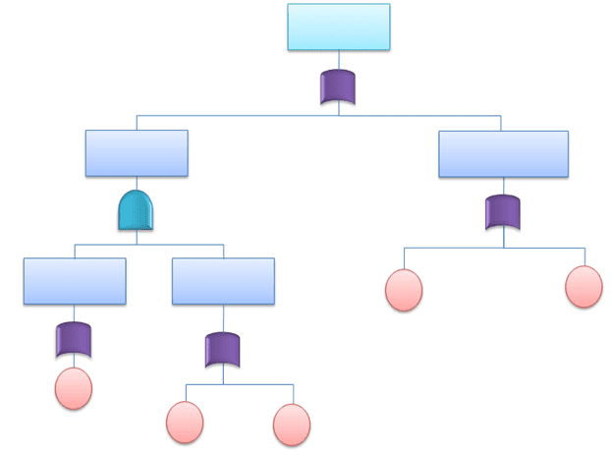FTA Diagram

## **History of Fault Tree Analysis**

Fault tree analysis is a top down approach that was originally developed in Bell laboratories by H Waston and A Mearns for the air force in the year 1962. This concept later adopted by Boeing and today it is widely used in aerospace, automobile, chemical, nuclear and software industries especially reliability and safety related events.

## When Would You Use FTA

Fault tree analysis can be used to perform for all types of system level risk assessment process. The purpose of FTA is to effectively identify cause(s) of system failure and mitigate the risks before it occurs. This is an invaluable tool for complex systems that visually displays the logical way of identifying the problem. Moreover system efficiency can be attained by this analysis. It can be implemented alone or complement to [Failure Mode and Effects Analysis (FMEA).](https://sixsigmastudyguide.com/failure-mode-effects-analysis-fmea/)

## FTA**Symbols**

Fault tree uses logical gates to perform the analysis. There are numerous FTA symbols exists, but these are broadly divided in to two categories, Event symbols and Gate symbols.

#### Event Symbols in FTA

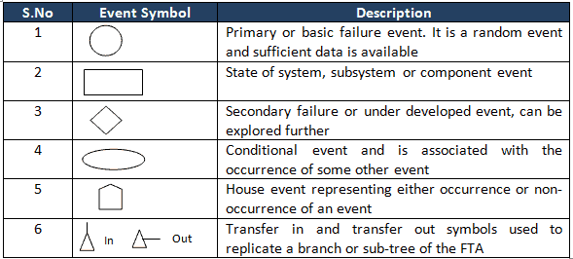

#### Gate Symbols in FTA

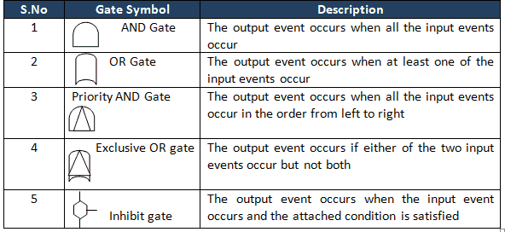

## How do you do Fault Tree Analysis

* Define the primary failure to be analyzed in other words identify the undesirable top event
* Identify first level contributors which are just below the top level using the available technical information
* Link these contributors to top level event by using logical gates (AND, OR gates), and also see the relationship, so that it will help to identify the appropriate logical gate
* Identify the second level contributors and link to top by using logical gates.
* Identify minimal cut set
* Repeat the same steps till the basic causes
* Finally complete and evaluate the FTA
* Calculate probability of lowest level elements occurrence and also measure the probabilities from bottom up
* 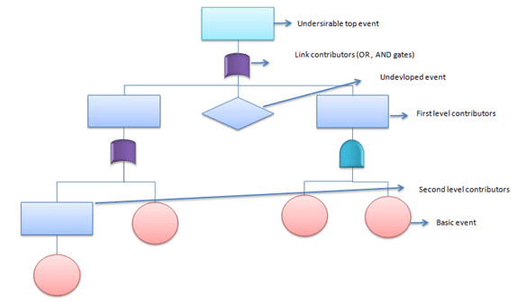

## **Minimal Cut Sets**

One of the important factors in qualitative analysis of fault tree is to identify minimal cut set. For instance complex and large fault tress have to use superior tools (algorithms for extraction) to get the minimal cut sets.

**Cut set:** A set of basic events that together cause the TOP undesirable event.

Ex: X, Y and Z (from the below picture)

**Minimal cut set:** A cut set with minimal number of events that can still cause the TOP undesirable event. In other words the TOP undesirable event occurs if one or more minimal cut set occurs.

Ex: (X and Y); (X and Z) from the below picture

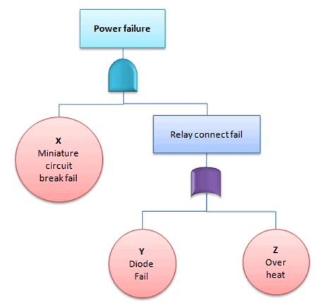

## Practical Example of FTA

A fire broke out at unit 1 of XYZ cable manufacturing company despite safety system in-place. General Manager was very concern about the accident and requests safety in-charge to evaluate the system. However as part of initial analysis of the existing system, safety team using FTA to identify the different causes for accident.

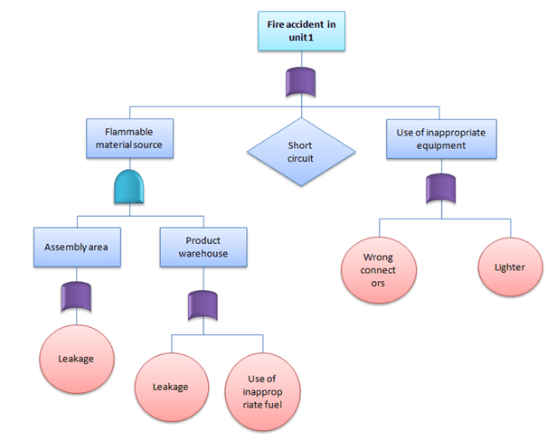

## **Quantitative Fault Tree Analysis**

Top undesirable event occurs if one or more of the minimal cut set occurs, hence the main target is to identify minimal cut sets. Moreover if all the minimal cuts are independent to each other, then we could compute the probability of top undesirable event by:

https://sixsigmastudyguide.com/wp-content/uploads/2020/02/f6.png

Where Pj is the failure probability of minimal cut set

**Example:**Find the probability of water pump failure from the below example

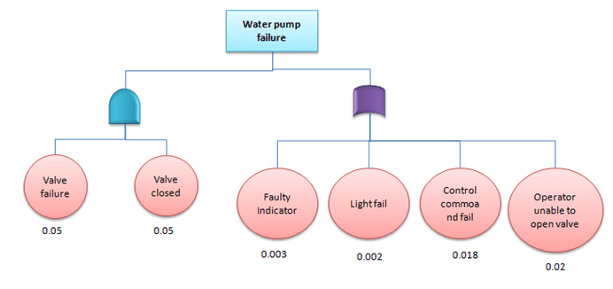

The water pump will fail because of value failure and value closed or fault indicator or light fail or control command fail or operator unable to open valve. Since OR gates add and AND gates multiply the probability of pump failure

μpumpfail=1-(0.05*0.05)*(1-0.003)*(1-0.002)*(1-0.018)*(1-0.02) = 0.0448

Hence, the probability of water pump failure = 4.48%

## **Advantages of Fault tree** analysis

* Fault tree visually depict the analysis that will help team to work on cause of event in logical way that leads to failure
* Highlights the critical components related to system failure
* Provides an efficient method to analyze the system
* Unlike other analysis methods, human errors are also include in the analysis
* It helps to prioritize the action items to solve the problem
* Provides qualitative and quantitative analysis

## **Disadvantages of Fault tree** analysis

* Too many gates and events to be consider for large system analysis
* The basic disadvantage is that it examine only one top event
* Common cause failures are not always obvious
* Difficult to capture time related and other delay factors
* Needs experienced individuals to understand the logical gates

## **Fault Tree Analysis Example in Detail**

Below is an example of a fault tree analysis in an electric power system:

**Top event:**[short-circuit fault](https://www.electronicshub.org/types-of-faults-in-electrical-power-systems/)  
[OR gate connecting top event to 1A and 1B]

* **Intermediate event 1A:** breakdown of transmission lines  
  [OR gate connecting 1A to 1A-2A and 1A-2B]
  + **Intermediate event 1A-2A:**[conductor resistance](https://www.hindawi.com/journals/jam/2014/146937/)
    - Basic event 1A-2A-3A: [rise in conductor temperature](https://chintglobal.com/blog/how-much-power-loss-in-transmission-lines/)
  + **Intermediate event 1A-2B**: [corona loss](http://large.stanford.edu/courses/2010/ph240/harting1/)
    - Basic event 1A-2B-3A: ionization of air molecules near  
      the transmission line conductors
* **Intermediate event 1B:**[transformer failure](https://electrical-engineering-portal.com/11-major-causes-of-power-system-failures#2)
  + **Intermediate event 1B-2A:** insulation failure  
    [INHIBIT gate connecting 1B-2A to 1B-2A-3A and conditioning event]  
    Conditioning event: fault current passes through transformer
    - **Intermediate event 1B-2A-3A:** sufficient insulation deterioration  
      [OR gate connecting 1B-2A-3A to 1B-2A-3A-4A and 1B-2A-3A-4B]
      * **Intermediate event 1B-2A-3A-4A:** thermal aging
        + Intermediate event 1B-2A-3A-4A-5A: excessive temperature

Basic event 1B-2A-3A-4A-5A-6A: transformer overloads

* + - * **Intermediate event 1B-2A-3A-4B:** [mechanical stress](https://www.industrial-electronics.com/epemt_1f.html)
        + Basic event 1B-2A-3A-4B-5A: transient power frequency currents

The above fault tree analysis example in a visual format:

Note: The events at the bottom have been labeled as basic events to show a “complete” fault tree analysis. However, the events can still be broken down further and are not the “true” root causes of a short-circuit fault problem.

Disclaimer: Since the focus of this example is to show a fault tree analysis, other technical elements relating to a short-circuit fault may be incorrect.

## **Application of Fault Tree Analysis**

The most critical part of fault tree analysis is the evaluation of the fault tree diagram. Using the diagram as a visual representation of failure paths, safety and reliability engineers can better identify which elements need to be removed or modified to prevent failure.

Beyond simple identification of failure hazards, the gate and event symbols also help safety and reliability engineers strategically plan for how best to attack failure. They are able to know when and where they should add failure control measures and prioritize and allocate resources accordingly.

Another benefit of fault tree analysis is the ability to get [Common Cause Failures](https://www.ntnu.edu/documents/624876/1277046207/SIS+book+-+chapter+10+-+CCF+definition+and+classification/b6b58f95-3d5a-4860-9b6f-a54493786bdd) (CCFs) when comparing the events of multiple fault trees within a single system. CCFs can be described as the highest priority risks to a system’s safety and reliability.

Since these elements are the most likely to cause failure within a system, CCFs should be closely monitored to help prevent them from going further up failure paths and causing overall system failure.

Ref:  https://sixsigmastudyguide.com/fault-tree-analysis/

https://safetyculture.com/topics/fault-tree-analysis/

Last modified: Wednesday, 12 October 2022, 2:31 PM

S

# Fault tree analysis examples

Some examples and explanation of Fault tree analysis

Click <https://www.youtube.com/watch?v=dKtIG0UXS6Y> link to open resource.

# How to Operate Fire Extinguisher - Fire Safety Training

Completion requirements

**Done: View**

Online demonstration

Click <https://www.youtube.com/watch?v=w4jHpHoYZhk> link to open resource.

# Fire Hose Drill Training Video

Completion requirements

**Done: View**

Online Demonstration

Click <https://www.youtube.com/watch?v=E4FVmr8pvtM> link to open resource.

# Fire Fighter Ladder Drill

Completion requirements

**Done: View**

online Demonstration

Click <https://www.youtube.com/watch?v=Vg4furPr6O8> link to open resource.

# FIRE HOSE DRILL

Completion requirements

**Done: View**

Online Demonstration

Click <https://www.youtube.com/watch?v=0NH7y7CvLQ0> link to open resource.

# FIRE FIGHTING & EVACUATION MOCK DRILL

Completion requirements

**Done: View**

online demostration: https://www.youtube.com/watch?v=untYFvj7IgM

Click <https://www.youtube.com/watch?v=untYFvj7IgM> link to open resource.

# Fire Extinguisher & Fire Equipments Demo

Completion requirements

**Done: View**

online demonstration

Click <https://www.google.com/url?sa=t&rct=j&q=&esrc=s&source=web&cd=&cad=rja&uact=8&ved=2ahUKEwja9pfYj-PzAhVBSX0KHdw-ATMQtwJ6BAgVEAM&url=https%3A%2F%2Fwww.youtube.com%2Fwatch%3Fv%3DZ-xZAwqMtF8&usg=AOvVaw2SrhLe9B7uvkGLdYq6gA8a> link to open resource.

# Fire Safety Mock Burn Demonstration

Completion requirements

**Done: View**

Online Demonstration

Click <https://www.youtube.com/watch?v=LOC49uSeZWk> link to open resource.